1.Create an Angular application with title 'Calculator'.
Create a form with two textboxs with id as 'textbox1' and 'textbox2'.
Create 4 buttons namely 'Multiply','Divide','Add','Subtract'.
If we enter two values and click any button the respective result should be displayed.The result should be created with id as 'result'.

Expected Screens:
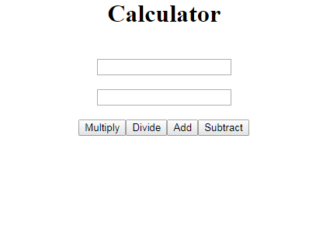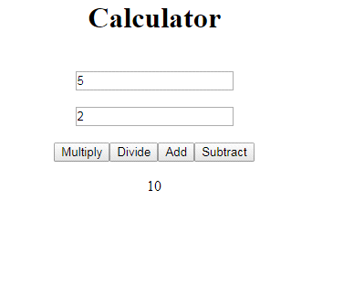
2.Create an Angular application with title 'Calculator'.
Create a form with two textboxs with id as 'textbox1' and 'textbox2'.
Create two button namely 'Multiply','Divide','Subtract'.
If we enter two values and click any button the respective result should be displayed.The result should be created with id as 'result'.

Expected Screens:
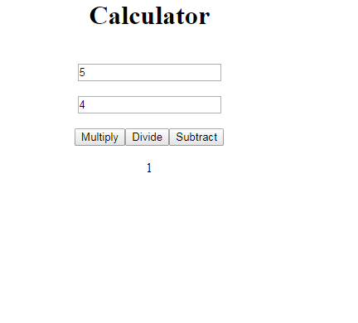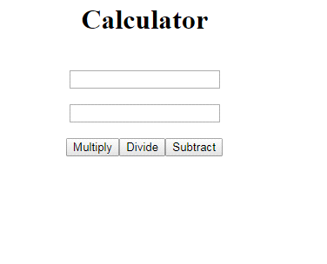

3.Create an angular application to display the country and city name based on the selected item.
Create the following textfields:
1. dropdown for country with id as "get".
2. dropdown for city with id as "put"
Display the result with id as "result" as shown in the given expected screens.
Expected Screens:
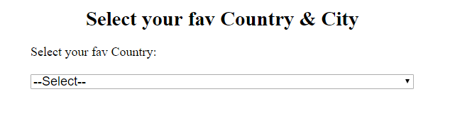
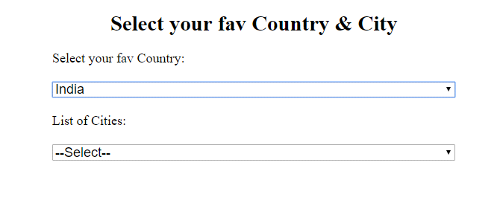
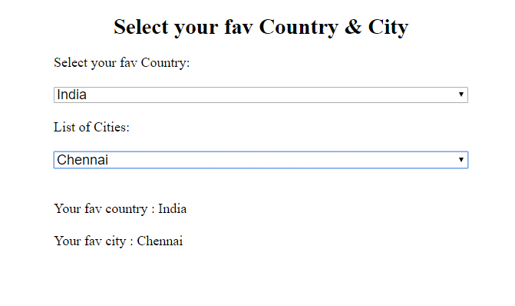
4.Develop an angular application to convert the given number to Milli,centi,Deci,Deca,Hecto,Kilo
Create a textbox with id as "meter" and 6 buttons named as Milli,Centi,Deci,Deca,Hecto,Kilo respectively.
Display the result with id as "result" as shown in the given expected screens.
Expected Screens:
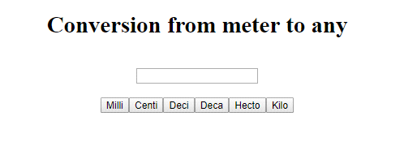
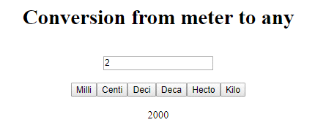

5.Create an Angular application.write the code to display the following
"{ id: '1', firstName: 'Roshini', lastName: 'Sundar', email: 'roshini@gmail.com' },
{ id: '2', firstName: 'Guna', lastName: 'vignesh', email: 'guna@gmail.com' },
{ id: '3', firstName: 'hema', lastName: 'selvaraj', email: 'hema@gmail.com' },
{ id: '4', firstName: 'safana', lastName: 'abdul', email: 'safana@gmail.com' },
{ id: '5', firstName: 'raji', lastName: 'jayakumar', email: 'raji@gmail.com' }".
1.Print the above Json value in table format with id as result.
2.In the above Json values the firstname should be in uppercase.Given the firstname with id as firstname.
Expected Screens:
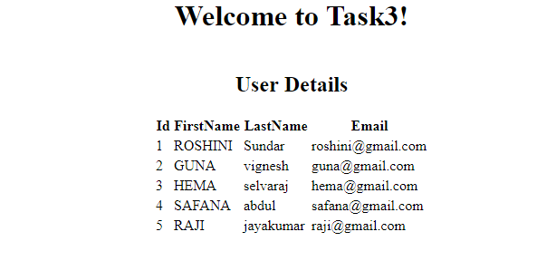

6.Create an Angular application.write the code to create the form that has 1 textbox
1.with classname as fortextbox
2.button as change with classname as button
Display the given input in uppercase and lowercase output with id as uppercase and lowercase respectively.(using pipes)
Expected Screens:
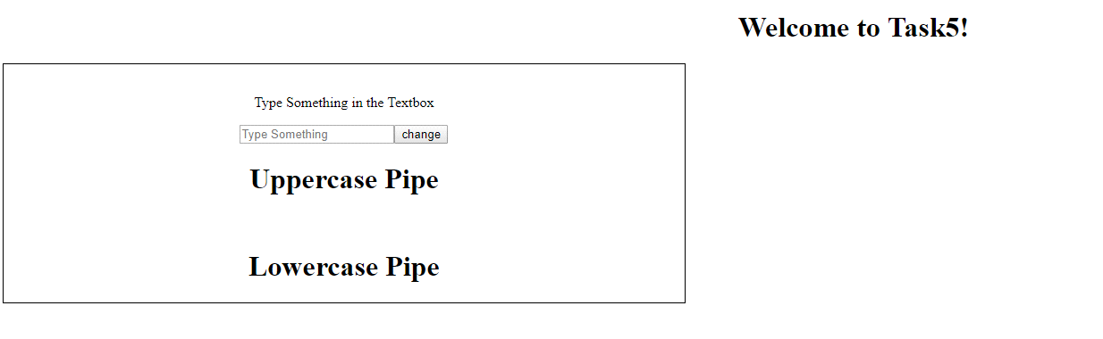
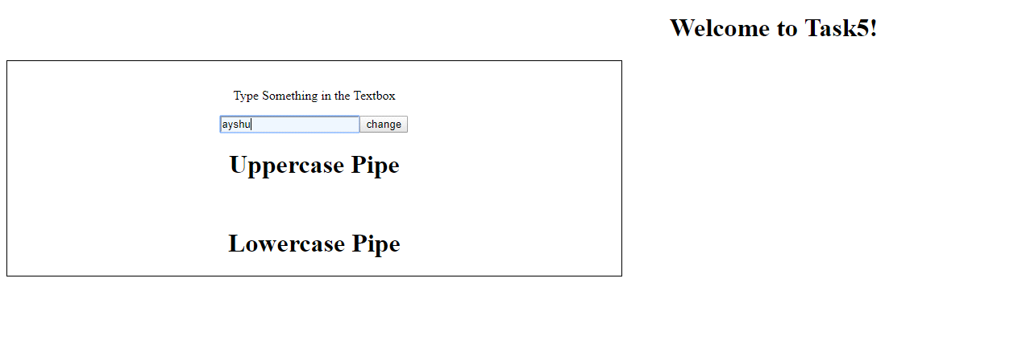
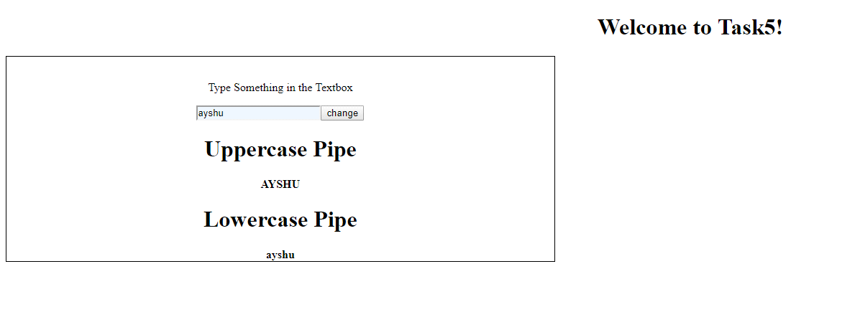
7.Create an Angular application and display the title as "Welcome to Task6!".Get the today's date as input and Display
1.Date as d/M/y format with id as result1
2.Date as shorttime with id as result2
Refer screenshot
Expected Screens:
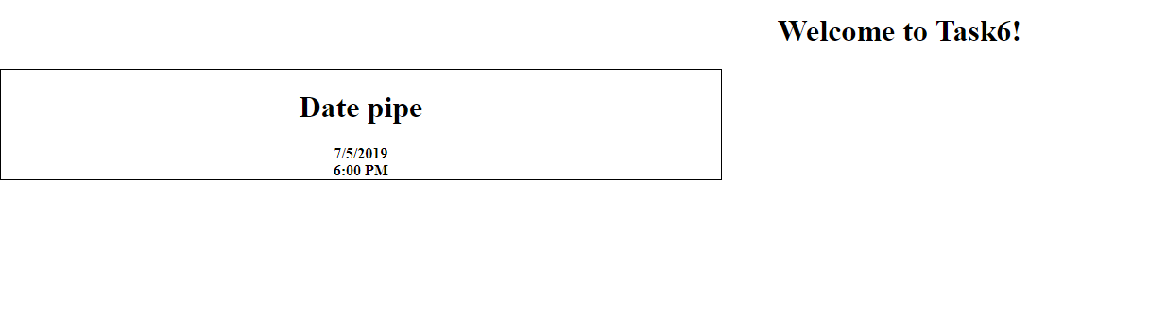
8.Create an angular application to display the entered text.
Create a textbox with id as "values" and button with id as "addv". Display the result with id as "result" as shown in the given expected screens.
Expected Screens:
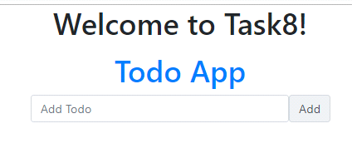
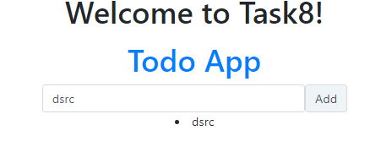

9.Create an angular application to display the difference based on the given inputs.
Create 2 textboxes From and To with id as "scorefrom" and "scoreto" respectively and a button with id as "button".
Display the result with id as "result" as shown in the given expected screens.
Following are the criteria to display the result:
1.If From value is greater than To value, display a message as "From value is Greater"
2.If From value is smaller than the To value, display a message as "To value is Greater"
3.If both the values are equal, display a message as Both values are Equal
Expected Screens:
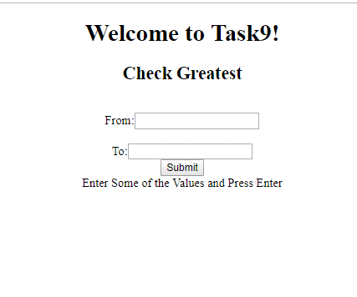
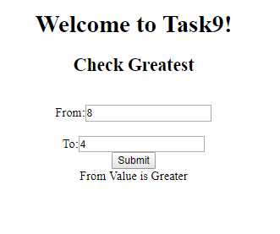
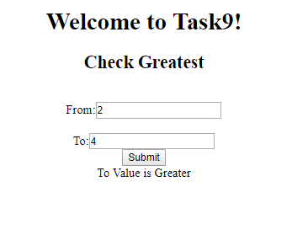
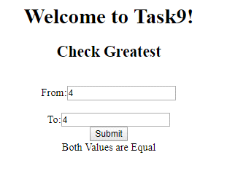
10.Create an angular application to display the text based on the slices.
Create a textbox with id as "values" and a button with id as "addv".
Display the result with id as "result"
Note:from second value till fifth value must be sliced
Expected Screen:
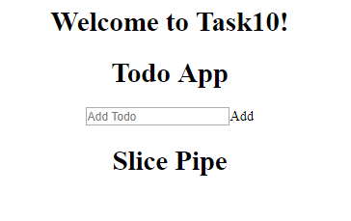
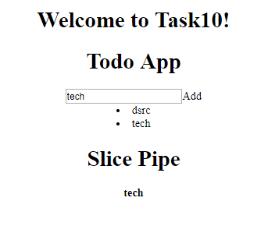
11.Create an angular application to calculate the BMI value for the given weight and height.
Create two textboxes with id as "height" and "weight" respectively and a button with id as "calculate".
Display the result with id as "bmi" as shown in the ggiven expected result.
Expected Screens:
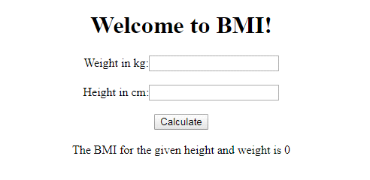
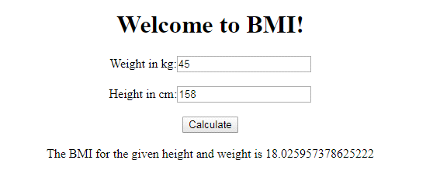
12.Create an angular application to calculate the BMI of a person with repect to the given weight and height.
Create two textboxes with id as "weight" and "height" respectively and a button with id as "calculate".
Display the reult with id as "result" as shown in the given expected result. Calculate the BMI based on the following criteria:
1. If the BMI value is between 25-29, then display as "Overweight"
2. If the BMI value is between 30-34, then display as "Obesity with low risk"
3. If the BMI value is between 35-39, then display as "Obesity with moderate risk"
4. If the BMI value is above 40, then display as "High Obesity"
Expected Screens:
